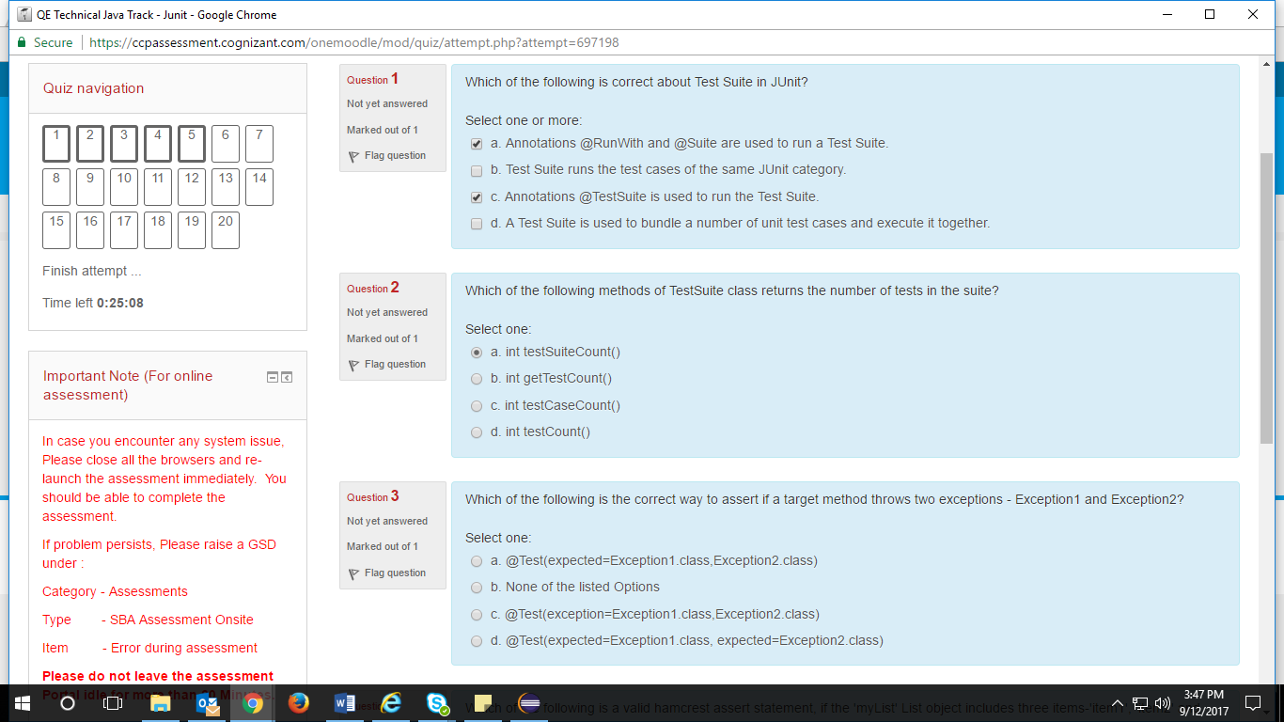

1. @RunWith and @**Suite annotations** are **used to run** the **suite tests**

B

D

1. int testCount()
2. b. none of the listed options

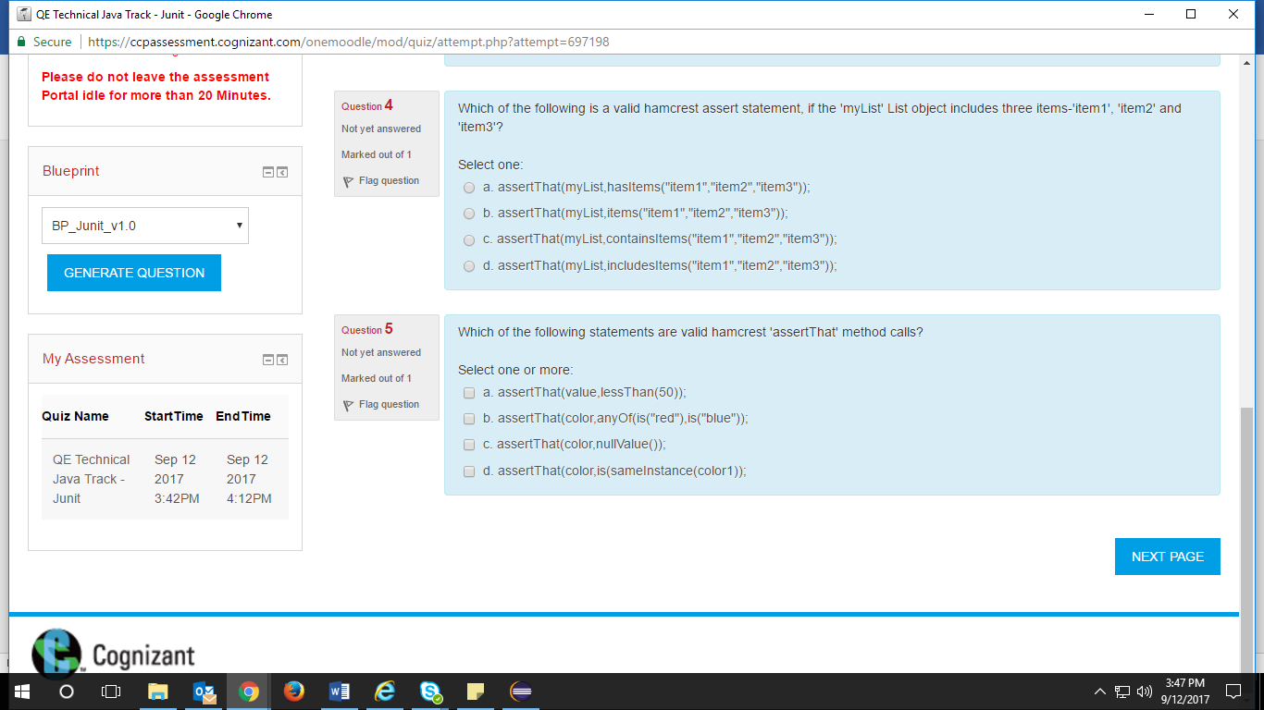

1. c
2. d,b

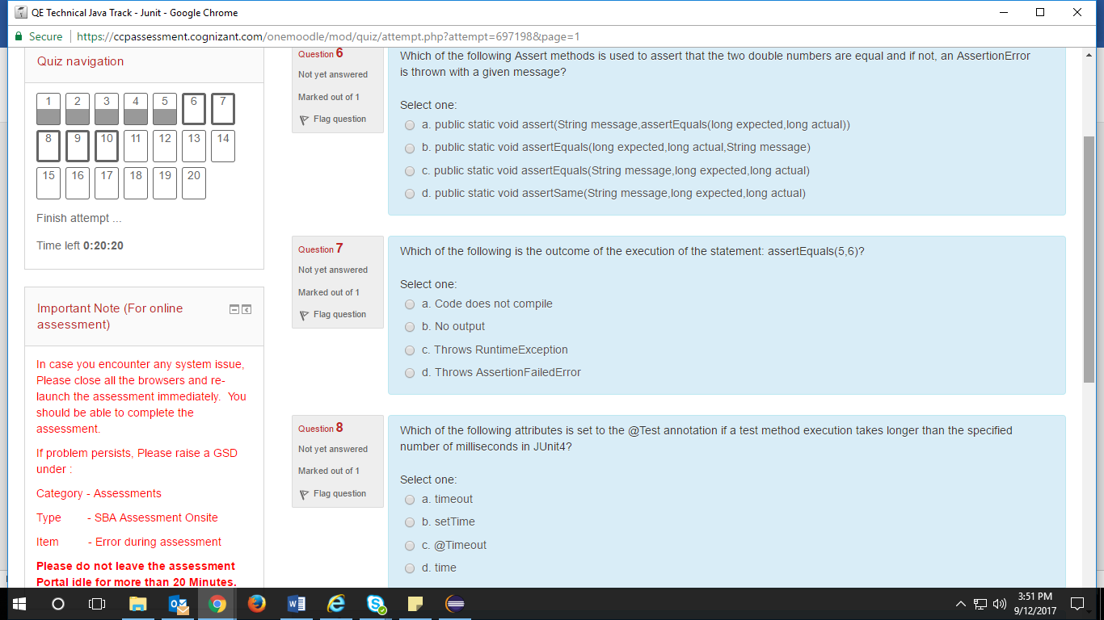

1. c
2. d – assertion failed error
3. a. timeout

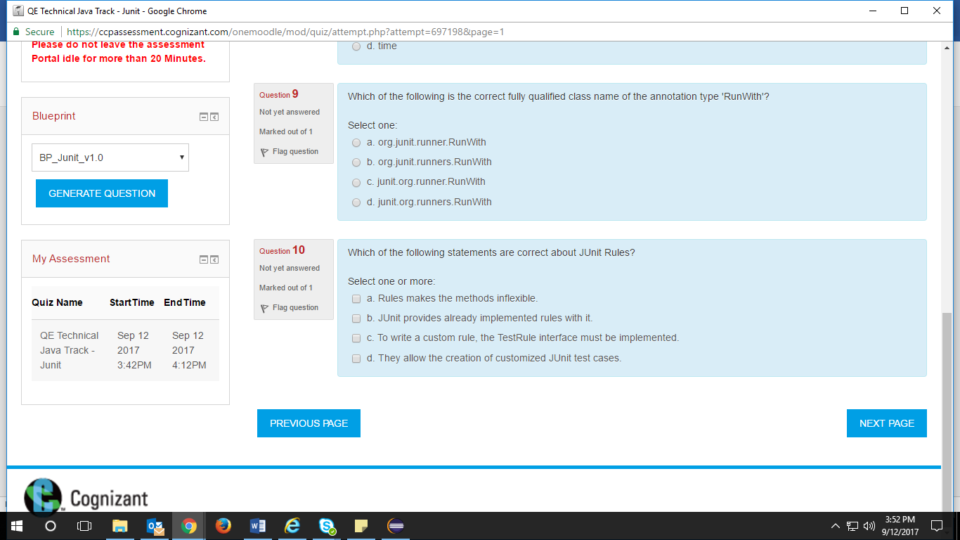

1. a
2. b,c,d

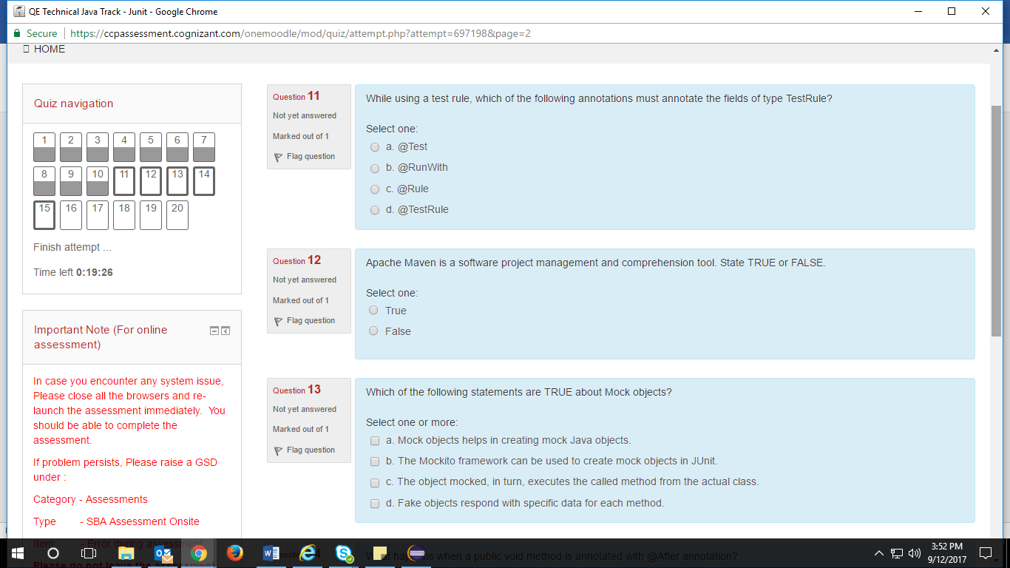

1. c @Rule
2. True
3. B,d

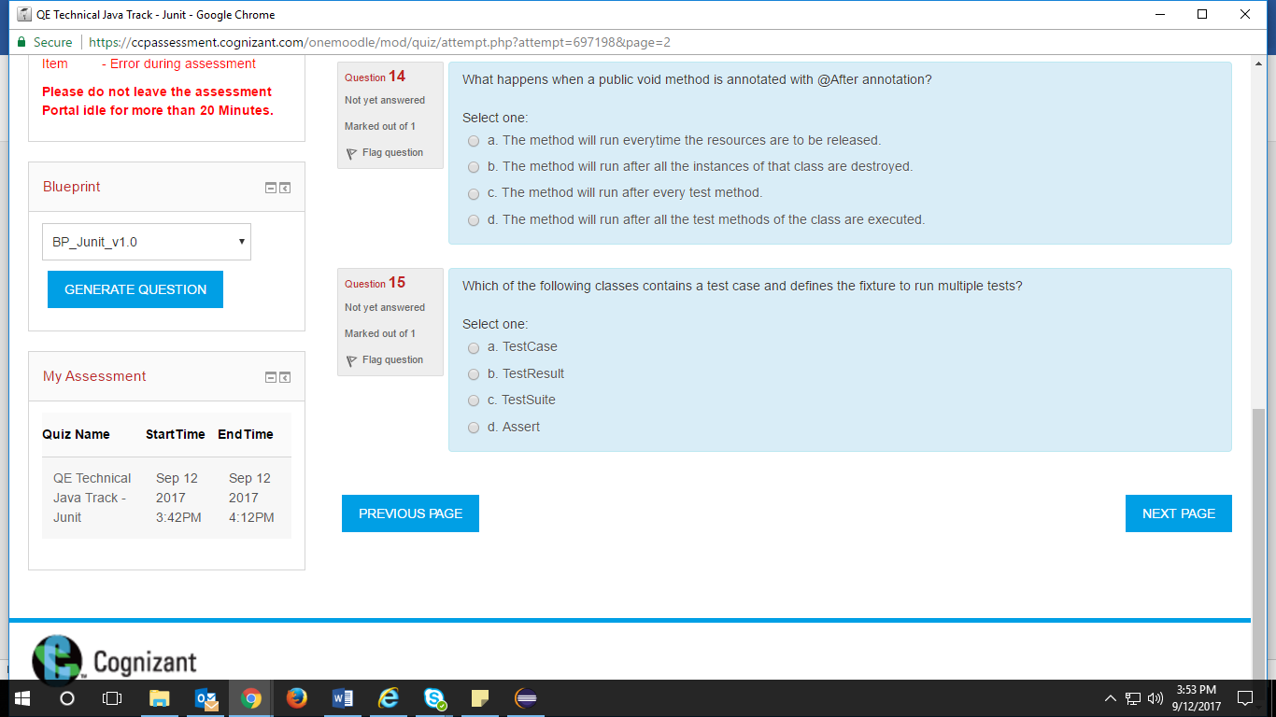

1. C
2. a

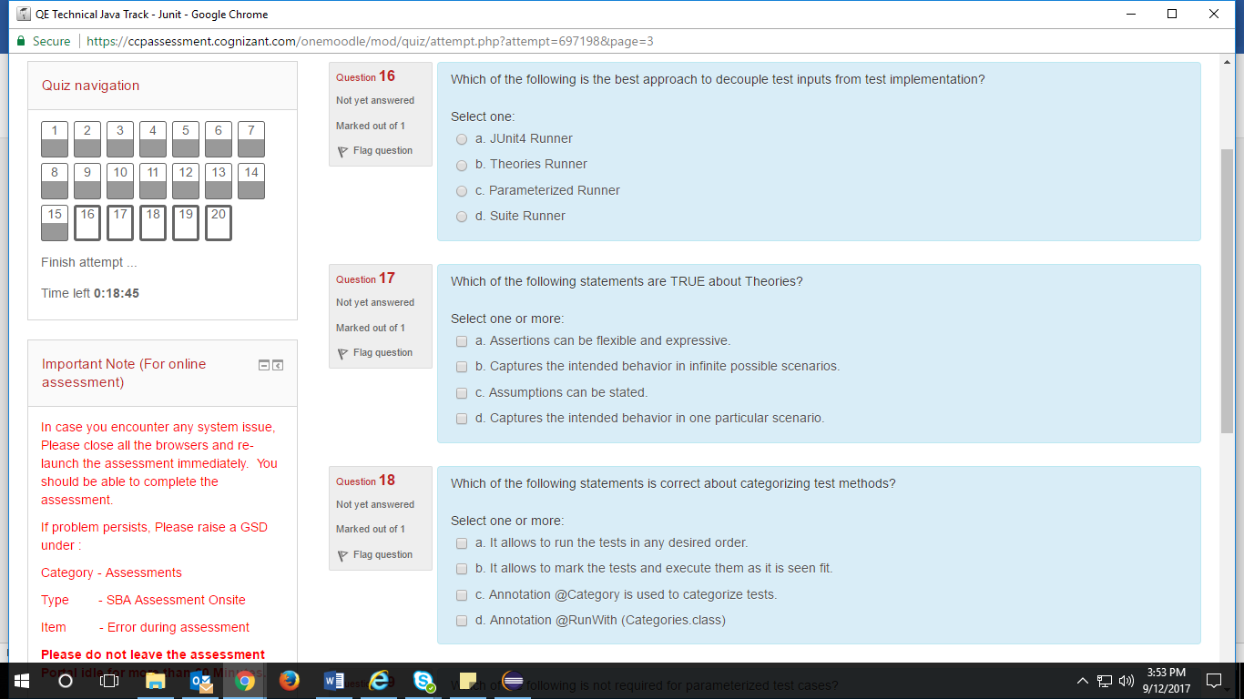

16.

17. a,b, c

18. a,d,c

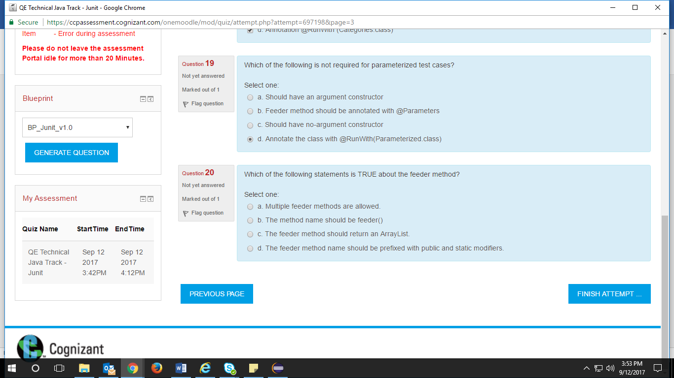

19. c

20.d